**FINAL PROJECT DATA MODELLING**

**INFO 5707**

**RUSHITHA KONDREDDY**

**PHARMACY MANAGEMENT SYSTEM**

Objectives:

In the United States, pharmacies are a major element of healthcare and deal with the function of selling medical drugs. Most of the medications sold in a pharmacy, for example, cannot be bought without a prescription. There is a cap on the amount that can be, even with a signed prescription, acquired. In addition, pharmacists may conduct a background check on the medical history of the client. To ensure that substance addiction does not affect them. There are also other laws on pharmacy operations, such as the requirement for safe operations. Disposal, of expired medicine and license requirement for staff mixing / preparing the Narcotics. Therefore, preparing a pharmacy database management system not only requires studying how to things are handled from the point of view of a client or employee, as well as the relevant laws. The aim of this project is to develop a comprehensive system that could deal with challenges confronted by the daily operation of a modern pharmacy.

User requirements:

Arrived at the following criteria based on the pharmacy flow during the design phase:

1. Customer:

When a customer usually arrives at the pharmacy, based on their SSN, we first identify them. Then they are asked for their name, DOB (date of birth), mobile number, gender and residential address in case they are new customers. Under the Omnibus Budget Reconciliation Act of 1990, the address and date of birth are expected to be registered for drug prevention purposes.

1. Insurance:

There is health care coverage for 89.6 percent of the US population (National Center for Health Statistics, 2017). ACA (also called Obamacare) greatly increased the coverage. One of the reasons for high coverage is that medical expenses in the country are very high and a significant majority of the population cannot afford healthcare without insurance. In case a customer has health insurance, we store their insurance Id which is unique for every single customer, company name, start date, end date and co-insurance. Co-Insurance is a proportion of the amount charged for a medical purchase by the insurance provider (Managing your healthcare expenses, n.d.). The device should be able to determine the amount charged by the insurance provider and the customer automatically, taking into account the customer's SSN and insurance ID.

1. Employee:

An employee has the same information as a client, but a business ID is also provided to them which is unique to them. Each of the following positions must be filled by an employee:

1. Pharmacist A pharmacist

2. CPhT (Certified Technician for Pharmacy)

3. Intern (can work part time in the pharmacy)

4.  Cashier

All other positions include a license from the State Medical Board, aside from the cashier, as they deal specifically with drug mixing and planning. We are following the laws of the state of Texas for the purpose of this article.

1. Prescription:

Only with a prescription most of the medications in the pharmacy be sold. A prescription requires the SSN of the consumer, the prescribing ID of the doctor (required by law) and when the prescription has been prescribed. Each, prescription includes a variety of prescribed medications, each of which has a drug name, quantity and refill cap. By law, a pharmacy is unable to sell more than the amount prescribed or anything not specified on the prescription. Under, CASA (1970), the prescription is expected to be kept.

1. The Request:

From the prescription, an order is created. This information needs to be separately stored because customers may:

1. Buying less medication than specified in the prescription

2. For refills based on the same prescription, come back

Each order has a unique order ID, which is allocated by the device automatically. Each order can have several medications, each with the quantity and price ordered. We also record the drug's batch number. The government can request this information under Extensive Substance Abuse Prevention and Control Act (CASA) and has to be stored.

1. Bill:

A bill is created by the system until an order has been completed. This bill is handed over to the customer and includes order details, insurance information as well as breakdown of amount paid. The system should measure the breakdown automatically based on insurance, customer and medication data.

1. Medicine (Stock):

Drugs are split into over the counter", "restricted" and only prescription." Federal Legislation only divides limited medications into 5 schedules and allows an inventory of "readily available" for schedule 2 drugs. While, not mandated by law anywhere it is good to store an up-to-date inventory for record keeping and to know when we run out of stock.

1. The Notifications:

Based on the following four cases, the device should be able to produce notifications:

1. The medicine stock is poor (less than 100 tablets)

2. In the next 60 days, certain drugs will expire.

3. For disposal, drugs are labelled

4. Drugs are easily disposed of.

The updates are sent to all the pharmacists who are employees.

Business Rules:

1. There can be several prescriptions for a single consumer. The relationship between them, therefore, is one of many.

2. A prescription consists of multiple medicines, so the relation is one to many. A prescription can generate multiple orders in the event of refills. So, this relationship is one of many, too.

3. Different medications may be used in a single order, so partnerships are one to many. However, one order will produce only one payment. Thus, one-to-one is the relationship between bill and order.

4. A client may make several transactions and thus one to many is the relationship between customer and bill. This is due to the fact that every bill has only one customer.

5. In the medication table (stock), each drug we have in stock can be uniquely described by the drug name and batch number. It is presumed that the batch number is unique among suppliers.

6. Disposed drugs are weak entities and it uses the foreign key drug name and batch number as their primary key.

7. One worker can receive multiple alerts and multiple workers can be given one notification, so relationship is many to many.

8. The same drug can be disposed of by several workers. Likewise, several medications may be disposed of by one worker. Therefore, there is many to many relationships.

9. Many orders can be prepared by one employee. However, only one employee can prepare a particular order. Therefore, partnerships are one for many.

ER-Diagram



DATA DICTIONARY:

|  |  |  |  |  |  |  |  |  |
| --- | --- | --- | --- | --- | --- | --- | --- | --- |
| Table name | Attribute name | Contents | Type | size | PK or FK | FK referenced table | Description |  |
| Customer | SSN  First name  Last name  Phone  Gender  Address  Date of birth  Insurance_id | The social security number, name of the customer,mobile number,address, date of birth and the insuranceID | INT  Char  Char  Int  Char  Char  Date  Int | 10  200  200  10  1  1000  10 | PK  FK | Insurance |  |  |
| Insurance | Insurance ID  Company name  Start date  End date  Co-insurance |  | Int  Char  Date  Date  Int | 10  250  4 | PK |  |  |  |
| Employee | Employee ID  SSN  License  First name  Last name  Start date  End date  Role  Salary  Phone number  Date of birth |  | Int  Int  Int  Char  Char  Date  Date  Char  Int  Int  Date | 5  10  10  255  255  255  4  10 | PK |  |  |  |
| prescription | Prescription ID  Ssn  Doctor ID  Prescription Date |  | Int  Int  Int  date | 10  10  10 | PK  Fk | customer |  |  |
| Prescribed drugs | Prescription ID  Drug name  Prescribed quantity  Refill limit |  | Int  Char  Number  number | 10  225  10  10 | fK  fk |  |  |  |
| Order | Order id  Prescription ID  Employee ID  order date |  | Int  Int  Int  Date | 10  10  5 | **PK**  **Fk** | prescription |  |  |
| Order drugs | Order id  Drug name  Batch number  Quantity  Price |  | Int  Char  Int  Int  Int | 10  255  10  10  2 | Fk  Fk  Fk | Order  medicine |  |  |
| Bill | Order id  Customer ssn  Total amount  Customer payment  Insurance payment |  | Int  Int  Int  Int  Int | 10  10  4  4  4 | Pk  Fk | Order  Bill |  |  |
| Medicine | Drug name  Batch number  Medicine type  Manufacturer  Quantity  Expiry date  Price |  | Char  Int  Char  Char  Int  Date  Int |  | Pk  Pk |  |  |  |
| Disposed drugs | Drug name  Batch number  Quantity  Company |  | Char  Int  Int  char | 255  10  10  255 | Fk  Fk | medicine |  |  |
| notification | Notification id  Message  type |  | Int  Char  char | 10  225  225 | pk |  |  |  |
| Employee_disposed drugs | Employee id  Drug name  Batch number  Disposal date |  | Int  Char  Int  date | 5  255  10 | Fk  Fk  Fk  Pk | Employee  Disposed drugs |  |  |
| Employee notification | Employee id  Notification id |  | Int  Int | 5  10 | Fk  Fk | Employee  Notification |  |  |

**DATA ENTRY and UPDATE QUERIES**

**1**)Create table customer and insert values into the customer table.

CREATE TABLE Customer (

SSN INT(10) NOT NULL,

FiRST_Name char(200),

LAST_Name char(200) NOT NULL,

Phone INT(10) NOT NULL UNIQUE,

Gender char(20) NOT NULL,

Address char(210) NOT NULL,

Date_of_Birth date NOT NULL,

Insurance_ID INT(10) NOT NULL UNIQUE,

PRIMARY KEY (SSN)

);

INSERT INTO CUSTOMER(SSN,FIRST_Name,last_name,phone,gender,address,date_of_birth,insurance_id)values(2345678,'kri','shan',980005675,'male','tacoma','1998-04-13',123);

INSERT INTO CUSTOMER(SSN,FIRST_Name,last_name,phone,gender,address,date_of_birth,insurance_id)

values(234943,'bri','sing',967890,'male','tacoma','1998-09-18',124);

select * from customer



2)Create table prescription and insert the values into it.

CREATE TABLE Prescription (

Prescription_Id int(10) NOT NULL,

SSN int(10) NOT NULL,

Doctor_Id int(10) NOT NULL,

Prescribed_Date date NOT NULL,

PRIMARY KEY (Prescription_ID)

);

insert into prescription( Prescription_Id,SSN,Doctor_Id, Prescribed_Date)values(123,2345678,345,'2020-09-12');

insert into prescription( Prescription_Id,SSN,Doctor_Id, Prescribed_Date)values(126,234943,349,'2020-10-12');

3)Create table prescribed_drugs and insert values into it.

CREATE TABLE Prescribed_Drugs (

Prescription_ID int(10) NOT NULL,

DrugName char(200) NOT NULL,

Prescribed_Quantity int(10) NOT NULL,

Refill_Limit int(10) NOT NULL,

PRIMARY KEY (Prescription_ID, DrugName)

);

insert into prescribed_drugs(Prescription_ID,DrugName,Prescribed_Quantity,Refill_Limit)values(123,'glysrine',10,3);

insert into prescribed_drugs(Prescription_ID,DrugName,Prescribed_Quantity,Refill_Limit)values(124,'glysrine',20,5);

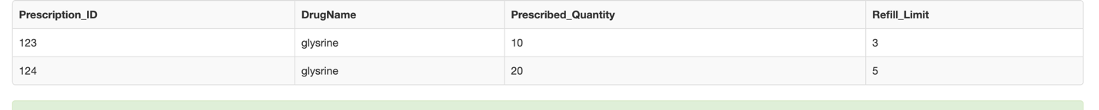

4)create table orders and insert values into it.

CREATE TABLE Orders (

Order_ID int(10) NOT NULL,

Prescription_ID int(10) NOT NULL,

EmployeeID int(5) NOT NULL,

Order_Date date NOT NULL,

PRIMARY KEY (Order_ID)

);

Insert into orders( Order_ID,Prescription_ID,EmployeeID,Order_Date)values(1,123,674,'2020-12-09');

Insert into orders( Order_ID,Prescription_ID,EmployeeID,Order_Date)values(2,124,675,'2020-10-09');

Insert into orders( Order_ID,Prescription_ID,EmployeeID,Order_Date)values(3,125,693,'2020-01-09');

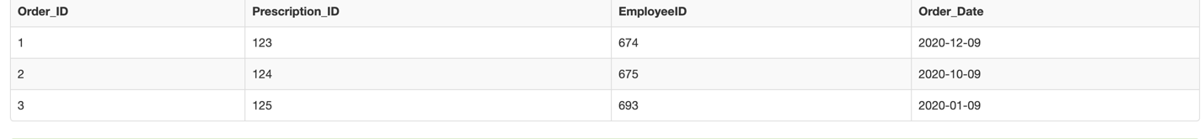

5)create table ordered drugs and insert values into it.

CREATE TABLE Ordered_Drugs (

Order_ID int(10) NOT NULL,

DrugName char(200) NOT NULL,

Batch_Number int(10) NOT NULL,

Ordered_Quantity int(10) NOT NULL,

Price int(2) NOT NULL,

PRIMARY KEY (Order_ID, DrugName, Batch_Number))

;

insert into ordered_drugs (Order_ID, DrugName,Batch_Number,Ordered_Quantity, Price) values(1,'glysrine',8,10,100);

insert into ordered_drugs (Order_ID, DrugName,Batch_Number,Ordered_Quantity, Price) values(2,'misto',7,10,1000);

insert into ordered_drugs (Order_ID, DrugName,Batch_Number,Ordered_Quantity, Price) values(3,'ninto',30,100,10000);

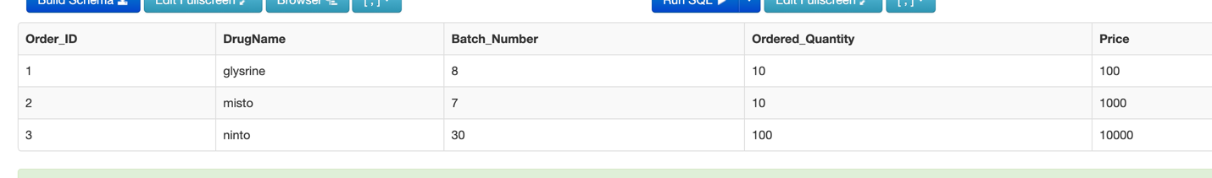

6)create table insur.ance and insert values into it

CREATE TABLE Insurance (

Insurance_ID int(10) NOT NULL,

Company_Name char(255) NOT NULL,

Start_Date date NOT NULL,

End_Date date NOT NULL,

Co_Insurance int(4) NOT NULL,

PRIMARY KEY (Insurance_ID)

);

insert into insurance(Insurance_ID,Company_Name,Start_Date,End_Date, Co_Insurance )values(2453,'gitcha','2019-12-24','2020-12-24',75);

insert into insurance(Insurance_ID,Company_Name,Start_Date,End_Date, Co_Insurance )values(3456,'dibog','2019-05-30','2021-05-30',25);

insert into insurance(Insurance_ID,Company_Name,Start_Date,End_Date, Co_Insurance )values(6789,'gotta','2019-08-24','2021-04-30',45);

7)create table employee and insert values into it.

CREATE TABLE Employee (

ID int(5) NOT NULL,

SSN int(10) NOT NULL UNIQUE,

License int(10) UNIQUE,

First_Name char(255) NOT NULL,

Last_Name char(255) NOT NULL,

Start_Date date NOT NULL,

End_Date date,

Role char(255) NOT NULL,

Salary int(4) NOT NULL,

Phone_Number int(200) NOT NULL,

Date_of_Birth date NOT NULL,

PRIMARY KEY (ID)

);

insert into employee(ID,SSN,License,First_Name,Last_Name,Start_Date,End_Date,Role,Salary,Phone_Number,Date_of_Birth)

values(1,345678,743,'deep','prem','2019-03-20','2022-04-30','medical assistant',2000,87900,'1992-03-30');

insert into employee(ID,SSN,License,First_Name,Last_Name,Start_Date,End_Date,Role,Salary,Phone_Number,Date_of_Birth)

values(2,345679,744,'krish','sri','2019-09-20','2022-09-30','medical assistant',2020,87800,'1991-04-30');

insert into employee(ID,SSN,License,First_Name,Last_Name,Start_Date,End_Date,Role,Salary,Phone_Number,Date_of_Birth)

values(3,345680,745,'dilee','mett','2018-03-20','2022-04-30','medical assistant',3000,9550,'1990-09-30');

9)create table medicine and insert values into it.

CREATE TABLE Medicine (

Drug_Name char(255) NOT NULL,

Batch_Number int(10) NOT NULL,

MedicineType char(255) NOT NULL,

Manufacturer char(255) NOT NULL,

Stock_Quantity int(10) NOT NULL,

Expiry_Date date NOT NULL,

Price int(4) NOT NULL,

PRIMARY KEY (Drug_Name, Batch_Number)

);

insert into medicine(Drug_Name,Batch_Number,MedicineType,Manufacturer,Stock_Quantity,Expiry_Date,Price)

values('glysrine',8,'painrelief','disha manufacturers',2000,'2023-03-25',100)



10) create table bill and insert values into it.

CREATE TABLE Bill (

Order_ID int(10) NOT NULL,

CustomerSSN int(10) NOT NULL,

Total_Amount int(4) NOT NULL,

Customer_Payment int(4) NOT NULL,

Insurance_Payment int(4) NOT NULL,

PRIMARY KEY (Order_ID, CustomerSSN)

);

insert into bill(Order_ID,CustomerSSN,Total_Amount,Customer_Payment,Insurance_Payment)

values(1,2345678,100,45,55)



11)create table disposed_drugs and insert values into it.

CREATE TABLE Disposed_Drugs (

Drug_Name char(200) NOT NULL,

Batch_Number int(10) NOT NULL,

Quantity int(10) NOT NULL,

Company char(255) NOT NULL,

PRIMARY KEY (Drug_Name, Batch_Number)

);

insert into disposed_drugs(Drug_Name,Batch_Number,Quantity,Company)values('singa',9,1000,'disha manufacturers')



12)create table employee_notification and insert values into it

CREATE TABLE Employee_Notification (

employeeID int(5) NOT NULL,

NotificationID int(10) NOT NULL,

PRIMARY KEY (EmployeeID, NotificationID)

);

insert into employee_notification(employeeid,notificationid)values(1,646);

insert into employee_notification(employeeid,notificationid)values(2,647);

insert into employee_notification(employeeid,notificationid)values(3,649);

13)create table employee_disposed_drugs and insert values into it

CREATE TABLE Employee_Disposed_Drugs (

EmployeeID int(5) NOT NULL,

Drug_Name char(200) NOT NULL,

Batch_Number int(10) NOT NULL,

Disposal_Date date NOT NULL,

PRIMARY KEY (EmployeeID, Drug_Name, Batch_Number, Disposal_Date)

);

insert into Employee_Disposed_Drugs(EmployeeID,Drug_Name,Batch_Number,Disposal_Date)values(1,'misto',631,'2020-05-23');

insert into Employee_Disposed_Drugs(EmployeeID,Drug_Name,Batch_Number,Disposal_Date)values(2,'ninti',637,'2020-08-23');

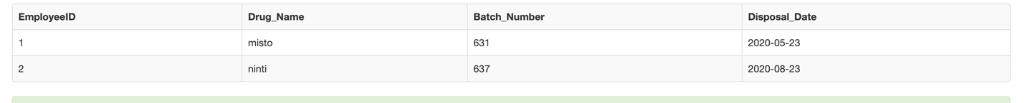

14)In the customer table we need to update the gender to female where the ssn =’ 234943‘

update customer set gender ='female' where ssn =234943;

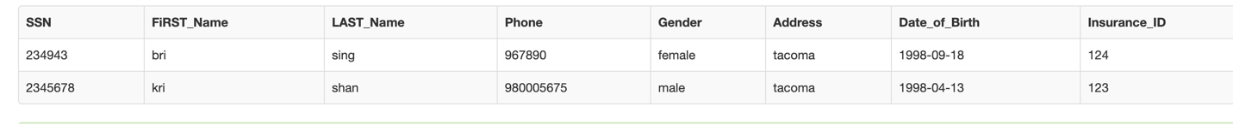

15)Changing the table name of employee_notification to notification_to_employee

ALTER TABLE Employee_Notification rename to notification_to_employee

16) We are adding email as a column to the employee table.

ALTER TABLE employee ADD Email varchar(255);

**DATA RETREIVAL QUERIES:**

**1)**Search in the database for the employee whose ssn =345680

select * from EMPLOYEE WHERE SSN =345680;

2)What are the different types of drugs in the drugs ordered by the customers ?

select distinct drugname from Ordered_Drugs;

3)select distinct company name where the co-pay is less than 100$

select distinct company_name,insurance_id,co_insurance from insurance where co_insurance<100;

4)Show the customer details along with their insurance details .

select customer.first_name,customer.last_name,insurance.insurance_id,insurance.co_insurance,insurance.start_date,insurance.end_date

from insurance left join customer on customer.insurance_id=insurance.insurance_id;

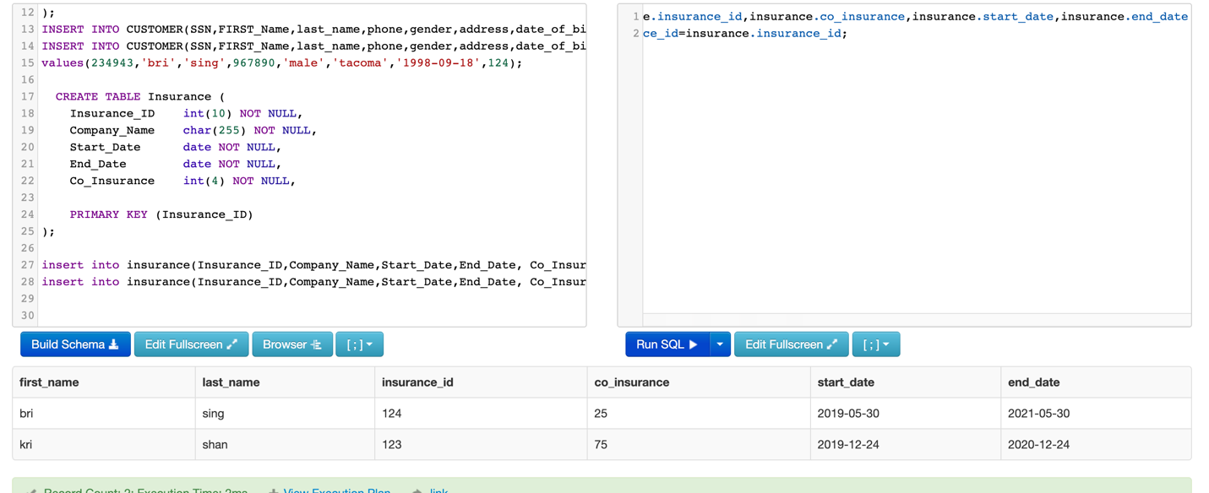

5)find the employee whose salary is greater than 2000$?

Select * from employee where salary>2000;

